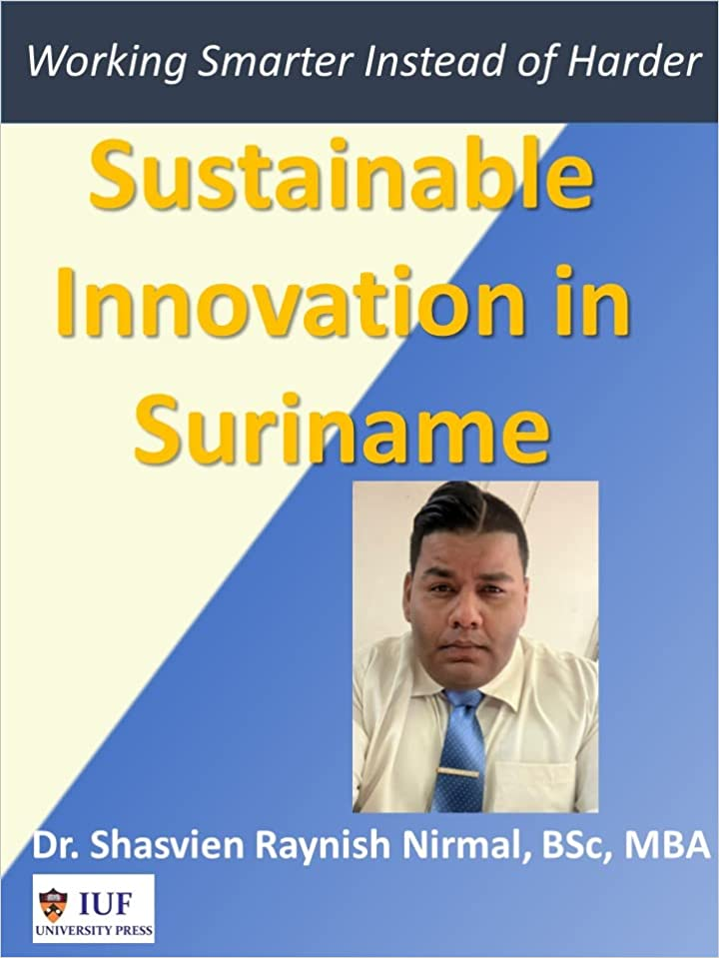
Shasvien Nirmal, Ph.D. holds a PhD from Technological University of the Americas, an MBA from European Global School, and a BSc Business Management from European Global School (all three cum laude). He is currently Associate professor at Technological University of the Americas in Suriname. He is author of the book “Sustainable Innovation in Suriname”.

