Alumni & Student Commentary
Christina Ross, Ph.D., Energy Medicine
JoAnn Salvisberg Smith, Ph.D., Teacher of English as a Foreign Language
Dam Thi Hoang Lan, MBBS, MBA
Jorge Alberto Alvarez Diaz, Human Sexuality
ASP Vasu Appu, LLB, MBA, DBA
James Pham Quang Thieu, MBA
Tommy P. Tucker, Community and Economic Development
Bethany Mowad, Mathematical Science
Tran Quoc Bao, MBA
Chiam Gek Eng, MBA, PSCM
Chew Joo Leong, MBA
Norazman bin Othman, MBA, DBA
Vicneswaran Rainasamy, MSc (Eng.), DBA
Le Thuy Oanh, MBA
Helen Slemons, Transpersonal and Consciousness Studies
Nguyen Kim Mai Thu, MBA
Lee Tee Yeow, MBA
Lim Te Hua, MBA
Chee Sook Chin, MBA
Lawrence Low Peng Kong, MBA
Jennifer Eklund, AA
Bui Le Hang, MBA
Mariam Abdullah, MBA
Huynh Thi Thu Huong, MBA
Ng Fook Heng, MBA
Pham Minh Long, MS in HRM
Alan Neo Bock Soo, MBA
Prabaharan A/L Subramaniam, MBA, DBA
Chang Siew Hong, MBA
Liu Shou Zheng, MBA
Tan Puah Khin, MBA
Law Yong Hoe, MBA
Mandarin Student Testimonials
Christina Ross
I am pleased to state that I was able to write my book, Etiology: How to Detect Disease in Your Energy Field Before It Manifests in Your Body, while studying for my PhD, due to the rigorous training I received at Akamai University. The challenging and interesting curriculum helped pave the way for my post-doctoral position, after I graduated. Send email to Christina Ross

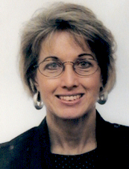
JoAnn Salvisberg Smith
Hello, my name is JoAnn Salvisberg-Smith and I have been teaching English to adults in Switzerland for fourteen years. I have taught learners at all levels in various types of courses including general, travel, exam, and business, both in the classroom and to private students. I am currently teaching teachers who need to brush up on their language skills, and business students in the University of Applied Sciences Business College in Luzern. I am completing the doctoral program in TEFL and especially appreciate working in the distance education mode as it allows me to work one-on-one with the instructors and streamline the courses to fit my teaching situation, experience and interests. My doctoral dissertation will focus on designing a framework for communicative skills assessment in the EFL classroom. Send email to JoAnn Salvisberg Smith
Dam Thi Hoang Lan, MBBS, MBA
Following my six-year degree at Hanoi Medical University, I worked for a while in the medical field before seeking a suitable MBA program provided by a foreign university. With so many foreign colleges to examine, my decision was pended for six months. I was quite impressed when I learned about Akamai University, the quality of their degree program, the fairness of their tuition, and the flexibility of their seminar schedule. I accepted an invitation to attend a sample HRM seminar module to review the quality of the Akamai program and after only two seminar sessions, I was convinced that the program was what I had hoped. I was fully satisfied with all aspects of the program, except for the fact that Akamai is not accredited by an agency recognized by the US Department of Education. Accredited college tuition is more than twice that of Akamai and still "unemployment" remains high for Vietnamese students completing programs at internationally accredited universities. I have discovered that Akamai"s program has the same qualities as the accredited colleges, and the knowledge level is equally high. I have access to professors that are excellent teachers and successful businessmen, a factor that I do not find in most professors at colleges in Vietnam. Akamai professors have provided me with a clear understanding of the international economy, current business trends, and they have imparted in me an attitude that we in Vietnam shall not be left behind the rest of the world. I have gained the knowledge needed to thrive in international competition, and will contribute effectively as Vietnam develops and integrates across the global economy. Akamai has made me a more confident entrepreneur, supporting my creation of my French Beauty Company. I have successfully linked my new work in the cosmetic industry with the work I previously did at leading pharmaceutical companies. I want to offer my sincere thanks to Akamai University, EDS Advance Academy and AITC-Vietnam for what I have attained. Send email to Dr. Dam Thi Hoang Lan
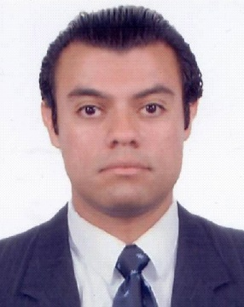
Jorge Alberto Alvarez Diaz
Hello! I am a Mexican physician working in several fields; one of them is clinical sexology. I am very proud to have completed the courses in Akamai University to obtain my Master of Sciences in Human Sexuality, because of that I am the first health professional in my city (and state) with this kind of postgraduate studies (revalidated by the Mexican government through the Ministry of Education) and certified as a Physician Specialist in Clinical Sexology by the FLASSES (Federacion Latinoamericana de Sociedades de SexologÃa y EducaciÃ³n Sexual, Latin American Federation of Societies of Sexology and Sex Education). Nobody has obtained that in Chihuahua, Mexico! Akamai has great flexible programs and wonderful teachers, such as Stanley Krippner, Ph D. I would like to thank Akamai and Dr. Krippner for all their guidance to help me obtain my final degree. Send an email to Dr. Jorge Alberto Alvarez Diaz
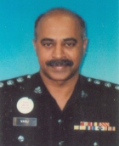
ASP Vasu Appu, LLB, MBA, DBA
I am ASP Dr. Vasu Appu, and I am attached to the Royal Malaysian Police Force with the rank of Assistant Superintendent of Police in my 29th year of service. Currently, I am a Senior Prosecuting Officer, attached to the Ampang Jaya Sessions Court, Selangor State in Malaysia. My nature of work involves prosecuting criminals connected in serious crimes cases, including drug trafficking, manslaughter, high profile cases of CBT and robberies of which a punishment of 20 years imprisonment is imposed if found guilty at trial. To conduct a full trail in court one has to have considerable knowledge, self-confidence, integrity and professionalism. As an Officer of the court, my mutual role is to support the 'scale of justice' and ensure that "justice must always not only be done but seen to be done". Akamai University has permitted me to achieve what is required to become an excellent Prosecuting Officer. The knowledge and wisdom that Akamai has given me makes me stand out and equally tall among my learned friends from the Bar as well as from the Chambers. I salute Akamai in enhancing my knowledge and wisdom and providing me with the confidence to carry out my duties. Send email to ASP Dr. Vasu Appu
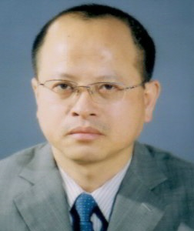
James Pham Quang Thieu, MBA
Hello, I am James Pham Quang Thieu from Hanoi, Vietnam. I started my MBA program with Akamai University in March 2005 and have completed the program in April, 2006. I am really impressed and quite satisfied with this program because of the following elements. In terms of time commitment, the program is suitable for busy people like me to attend the program. The teaching team is competent and professional in transferring new knowledge to the students. It is quite different from the method which I had when learning from teachers in our country. Akamai's methods focus on teamwork and discussion on the matters concerned, and by this way the students are always expected to creatively address the subject matter. The networking events organized by the University in Vietnam and Malaysia offer good opportunities for international students to meet up and exchange experiences with each other. Most of the basic knowledge which I have attained from the program is helpful for me in applying into my company's business operation. Are you busy business people? Do not lose your chance, come up with Akamai University. Send email to James Pham Quang Thieu
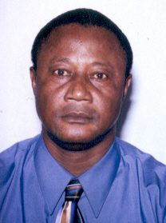
Tommy P. Tucker
Please be informed that I am really impressed by the contacts I have had with the professors working with me at the moment. I am convinced that I am not going to regret my choice of this university. In addition, the faculty is very much respectful to their students. They contact their students on time, and they always get back to them according to schedule. In addition, they encourage the students to come out with their own ideas. I do not consider the approach as a linear method of teaching. My contacts with both Dr. Menden and Dr. Phan encourage me to approach my learning from the perspective of "systems thinking", thus creating a "learning organization". My ideas are respected; I am encouraged to find out what others have said in my area of study, and then they let me see what they have said as a faculty. As long as a student looks at learning from this perspective, new knowledge is always created within a discipline. The most important tool that helps in this learning environment is the quality of the library. The library is well equipped, updated, and easy to use. The addition of Questia to the Virtual library is a plus, and another intellectual blessing. Let me say how grateful I am to the administration for their hard work. This team is very consistent, understanding, competent, and highly knowledgeable. With their co-ordination, and quick response to students, learning does not only become enjoyable, but students are indirectly being taught what it means to be successful after graduation, and to develop a sense of commitment and responsibility. I challenge any prospective students to give our university a try. Finally, "somebody with a scar is in a better position to recommend medication for a sore". Welcome on board! Tommy. Send email to Tommy P. Tucker
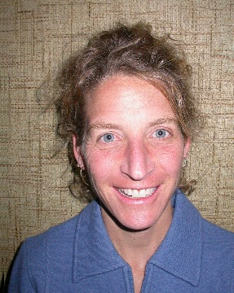
Bethany Mowad
Akamai offered a flexible, thorough program. With the assistance of my professors, I was able to create a degree program that was a perfect fit with my career goals. The professors were able to offer expertise in a variety of areas and always open to the discussion of ideas. I found the staff to be extremely knowledgeable and gifted at their various crafts. Most helpful was the availability of the professors. In a regular academic setting, I know that I would not have received as much personal attention and guidance. The professionalism of all that work at the university definitely inspired me to put forth 100% effort. I am proud of the work that I completed through Akamai. Send email to Bethany Mowad
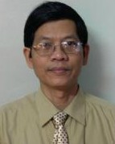
Tran Quoc Bao, MBA
Hello, my name is Tran Quoc Bao. I have been working with World Vision Vietnam, an international humanitarian organization. I would like to enter the world of production and business because Vietnam now has a growing economy and better conditions for doing business. I, therefore, took the distance learning MBA program organized by Akamai University with support seminars held in Malaysia. I made a good choice when I joined Akamai University. I felt satisfied with the schedules and study method provided by the program. By organizing support seminars on Saturday and Sunday, the program was suitable for those who are on-the-job learners. I appreciated the Malaysian professors with their experiences in international businesses who work as a bridge between academic matters and practical situations. The most valuable thing that I got from the MBA program was the way of strategic and creative thinking. Send email to Tran Quoc Bao
Chiam Gek Eng, MBA, PSCM
It's has been a great self-satisfaction and pride to me, to be able to study for my Master of Business Administration through distance learning with Akamai University. After a gap of many years from my last qualification, it is a personal challenge for me. I have needed to have strong time management skills to strike a balance between work, study and family. My persistent stamina has finally driven me to achieve the MBA degree within two years. I liked most about Akamai University their excellent facilitators and faculty members who delivered the latest knowledge and information during the nine modules of my program. It certainly created an opportunity for me to enrich myself and gain practical knowledge that will ultimately expand my career path. My MBA studies have changed my mindset and developed me into a highly self-confident personality that thrives on taking higher career challenges without fear of failure. I am presently working in Flextronics, a USA-based worldwide First Tier Contract Manufacturing Company. What I have learned in the Akamai MBA course is directly applicable to my job position as Regional Commodity Lead covering Singapore, Malaysia and India market for global purchase of electronic components. The beauty of the entire program is EDS/Global Synergy Network, which is a non-profit initiative fully sponsored by EDS Advance Academy Sdn Bhd, dedicated to all associates and friends in Asia and USA. It is a continuous learning, information and communication tool, which features weekly articles on personal and business development, latest management news and global trends from various sources. Current MBA students and MBA graduates are able to link through this excellent vehicle for expertise, comment, and advise. Being a member of the Akamai University alumni in Malaysia, I am able to participate in professional courses beyond the MBA degree. Recently, I completed a professional course by Akamai University in Professional Supply Chain Management, directly relevant to my scope of work. Although I have graduated from the MBA and Professional Supply Chain programs, I am still in touch with the EDS team on a regular basis for friendship and support and I am regularly kept informed of new and innovative professional programs that are developed by EDS and Akamai University as part of their continuous learning and community service project. Personally, the concepts and issues addressed by the program, not only have provided immense benefits to my professional and business needs, but my participation has improved my understanding of my family members and greatly enriched my management skill. Send email to Chiam Gek Eng
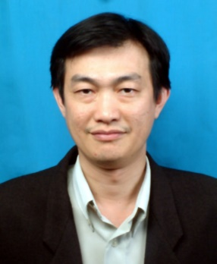
Chew Joo Leong, MBA
Hi All! My name is Chew Joo Leong. I am working as a Technical Solutions Manager and have been in the engineering field for almost two decades. Working with engineering issues today, is not as simple as it was a decade ago. It used to be very straightforward dealing with customers' issues. Today, the task of keeping the customer satisfied is different and much more demanding. Faced with new challenges and in need of the right tools to handle the situation, I was quite lucky when Prof. Pete Ooi introduced me to the Akamai MBA Program. The first residential tutorial that I attended was related to Marketing Management, in June 2005. This module enlightened me on the challenges that I was facing and provided me with the knowledge to develop needed strategies. After the first module, I attended eight more to complete the MBA at my own pace. The flexible MBA schedule is suitable for busy working adults like me, as my job assignments involve a lot of traveling. I had great fun, learning, sharing and making new friends during the tutorials. The MBA Program has provided me with the tools and the confidence that I needed and it has helped me to comprehend the technical issues from the business viewpoint. I would like to express my sincere thanks to the Akamai team for doing a terrific job throughout the MBA Program. It has been an enriching experience and I strongly recommend the program to working adults who seek to improve themselves.
Send Email to Chew Joo Leong
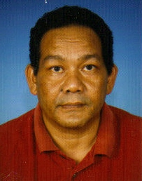
Norazman bin Othman, MBA, DBA
I am Norazman Othman, currently working with a foreign-based subsidiary company as a senior General Manager/Director. As a permanent employee, I am fully engaged with my daily workload and it is impossible for me to attend daily classes. Akamai University has made it possible for me to fulfill my dream, in a manner conducive to my needs. The Akamai programs are comprehensive, relevant and of high standard, and study at Akamai has proved to be quite appealing and rewarding for me and my fellow students. The lecturers, facilitators and support staff are very responsive, supportive and encouraging. Akamai programs emphasize application of knowledge within the real world of business. The coursework, group-projects and residential tutorials have helped me to broaden my perspective and strengthen my capabilities to further excel in my career and to make sound decisions in my workplace. I have applied the knowledge that I have gain in my daily work environment and it has shown remarkable results. My company has improved its performance and made enormous profit annually, which has benefited me considerably. I would sincerely urge those who are interested to bettering themselves to explore the Akamai learning experience. Send email to Dr. Norazman bin Othman
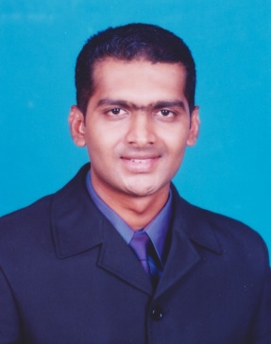
Vicneswaran Rainasamy, MS (Eng), DBA
I am Vicneswaran, from Penang, Malaysia. Despite being an Engineer, my career has been focused primarily in management and business analysis. My qualifications did not match my experience, proving to be a disadvantage in climbing the corporate ladder. My career took a turn for the better when I came across Akamai University's DBA program, where I learned to make the best out of both worlds and to achieve my goals in life. I am most impressed by educating techniques of Akamai that empowered me to think with an analytical and practical mind. Their system has helped me to build a broader network or colleagues and gain valuable friendships. The syllabi are structured in a way that has made the sea full of opportunities visible to me and has prepared me to grab them. Akamai has molded me to become an all-around expert in this sophisticated and competitive world of business management. I would like to express my deepest appreciation to our President of Akamai University, Professor Dr. Douglass Capogrossi, and to EDS program director, Dr. Ben Lee for their advice and productive ideas. I would like to thank the Akamai professors, especially my supervisor Dr. Premkumar Rajagopal, for their innovative ideas, useful comments and constructive discussion, where their commitment and enthusiasm have been a great impetus in achieving my goals. Send Email to Dr. Vicneswaran Rainasamy
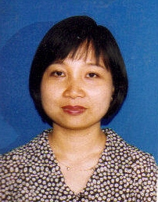
Le Thuy Oanh, MBA
Hello, my name is Le Thuy Oanh. I have been working for Dredging International, a Belgian dredging, marine engineering and environmental contractor for twelve years, since 1995. I started this advanced MBA program in March 2005 and completed the last assignment in August 2006. In my humble opinion, the Akamai program is advanced because the residential tutorials prove very useful, academically, and permits a chance for distance-learning students to gather and enjoy some very important social interaction with our classmates. I was able to create a great deal of business networking through my participation. The residential activities do much to increase the level and potential of our independent learning. Through the nine MBA modules, we were guided to accept change, to embrace it, and seek it out, expanding our opportunities to grow in a new and positive direction. This advanced program allowed me to become more self-confident. The program has helped me to find the best solutions to overcome the obstacles. As an outcome of my MBA studies, now, I am in a new position, Business Development Executive for the Vietnam and Cambodian markets. I thank my family, especially my mother, for providing unconditional support and encouragement. I would like to thank my company, Dredging International, and my boss Daniel Kong, for providing a scholarship for my studies, and sponsoring my trip to the Penang Convocation. My studies appear to have added value to my work performance. I would like to thank Akamai University and EDS Asia Pacific for a very advanced MBA program and for providing such great benefits to students who have limited time. Send email to Le Thuy Oanh
Helen Slemons
Hello. My name is Helen Slemons. For anyone interested in higher education by distance learning, I highly recommend Akamai University and its diverse programs. Although I was retired from careers in teaching and technical writing and held masters degrees in English, Technical and Scientific Writing, and Counseling, I still wanted to fulfill a long-held dream of earning a doctorate in transpersonal psychology. When I found Akamai University's distance learning program, I realized that I could expand my personal interest in and study of transpersonal psychology for the last quarter of a century into a formal program by enrolling in the doctoral program. This distance learning program met my needs for a flexible, affordable program in which I could contribute to the design of each course to study what most interested me while also meeting the university requirements. I especially liked the university's option flexibility in writing the doctoral dissertation. As a part of my project, I was permitted to design and create a website to offer online classes in Jungian studies, shamanism, journaling, and other personal growth areas. This website may be found online With the outstanding help and ongoing support of my mentor, Dr. Claudine Jeanrenaud and other great instructors, especially Dr. Sidney Homan and Dr. Penny Billman, I was able to complete my studies quite successfully in July, 2006. I am very grateful for the vision and dedication of Dr. Douglass Capogrossi to provide vision for Akamai University, a place where anyone, living anywhere in the world, even a 75-year-old mother, grandmother, and great grandmother living in retirement in Arizona, USA, like me, may continue learning and growing. Please email to Helen Slemons.
Nguyen Kim Mai Thu, MBA
Hi All, my name is Nguyen Kim Mai Thu. I am from Ho Chi Minh City, Vietnam. Learning is my non-stop dream. Since I was young, my mother always encouraged me to learn and over time, life-long learning has become one of my unchanging habits. After graduating from two universities in Vietnam, one major in English and the other in Tourism Administration, I started to work and have gained experience with large multinational companies in Vietnam, such as Unilever, Metro Cash & Carry, and Prudential, through which I have been well trained and developed. However, I have long dreamed of continuing with an official advanced academy. Luckily, in the later part of 2005, through a friend, I "discovered" Akamai. Wow! Despite all the time constraints for both work and family, I found that the distant learning MBA program offered by Akamai to be extremely well suitable for my needs. Moreover, the more I learned with Akamai, the more I recognized that I made the right decision. Thanks to all the great support I received from the dedicated instructors, Prof. Pete Ooi, Dr. Premkumar, Dr. Low Wei Hong, Ms. Sue Lim and especially the coaching and motivation provided by Dr. Ben Lee and Dr. Douglass Capogrossi, I was able to successfully finish my MBA program requirements. Actually, it was not easy to move from the traditional learning to distant learning, as it took a lot of time and effort to successfully complete my first assignments. However, as soon as I understood the principles of distant learning and became familiar with online communication, I found this program really beneficial. The Akamai model is quite appropriate for those who are working and studying at the same time. Finally, since completing the MBA, I have remained motivated, and have decided to continue toward the DBA, a path I would not have pursued before my enrollment with Akamai. Send email to Nguyen Kim Mai Thu
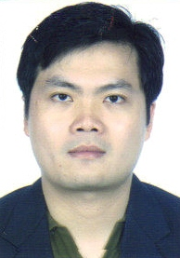
Lee Tee Yeow, MBA
Prior to joining the Akamai University MBA Program, I struggled with the decision to return to higher education, because of my busy workload and the long span of time since completing my Bachelor of Science in Electric and Electronics Engineering from USA. I was committed to completing an MBA by distanced learning, but needed a program that would be suitable to my busy professional schedule. As a technical lead cum system architect for equipment design in Agilent Technologies (M) Sdn.Bhd, a USA-based multinational company, I am required to study, analyze and evaluate new technologies in the market in order to produce our products with contemporary technologies. After joining the MBA program of, and attending series of lecture classes from different subjects which taught by different background of lecturers, I found the subject they taught was very useful and provided a lot of info regarding the working experience in their particular field and excellent knowledge delivered by them. Besides gaining the knowledge, there were also other program to simulate the theory such as playing game, discussion, presentation and etc. This is indeed; the sharing of knowledge is truly meaningful while working as technical lead in my current company to lead my group of engineers in designing the equipment. Though this MBA program is not accredited by accrediting agency in USA, but the program is par with other MBA offered by accredited universities either foreign or locally. The main attraction of joining this MBA program is because of excellent lecturers who delivered the latest management trends, flexible schedule to attend the class, and working experiences they had encountered during the past. Overall, my comment is the program is really enhanced my career such as changed my mindset for working attitude, developed my self-confident towards my job function, gain more practical knowledge in managing the product development, corporate management knowledge so that I could apply in my daily work. Last but not least, I would like to thank for Akamai University and EDS for implementing such flexible MBA modules for those working adult who desire to seek for self-improvement. Send email to Lee Tee Yeow
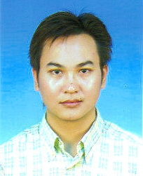
Lim Te Hua, MBA
After one and one-half years study with the MBA program launched by Akamai University, I found it has been really beneficial to my career and self- improvement. The nine modules of this program are carefully designed in a practical manner to closely apply to the current business environment. Since I have been appointed to develop the new business area related with chemical recovery line, the study of strategic management, marketing management and project management was highly effective. The MBA program has provided valuable information and expertise, which directly apply to my tasks and challenges. I am especially appreciative for the experienced professors who provided the latest information and practical examples, making the subject matter much easier to understand and apply. Thanks to the flexibility of Akamai's weekend scheduling for the residential tutorials, and excellent coordination by EDS Advance Academy, I was able to take advantage of this valuable opportunity. Send email to Lim Te Hua
Chee Sook Chin, MBA
Learning is the root of evolution of consciousness; a learning community will facilitate the growth of consciousness, both in the individuals involved and in its collective manifestation, the competency upgrading of the industries climate. I am grateful to Akamai University for granted me an opportunity to complete my MBA in Business, and highly appreciative to the Akamai faculty for their excellent guidance and patience in the long process of learning. My 18 months of learning was tough but useful, and it has proven to be invaluable to my practice. I am back on track, a part of today's new technological life style. My friends and business partners notice that I am a changed person, transformed into a more confident and effective business professional. I now tend to discipline my thinking and daily decision-making is no longer a difficult task for me. I have a profound sense of achievement that is reflected in improved performance in business. A key benefit of Akamai's MBA is the rich interaction that occurs among the globally diverse groups of executives and faculty that gather for the residential tutorials. This permits sharing of knowledge and solutions in tackling complex and rapidly changing global business challenges. Although I have completed my degree, the learning process will continue for me. Akamai's MBA program has helped me transform my learning habits, permitting me more efficient ways of learning new business ideas and strategies to adapt myself in today's market. I strongly believe that transformation is true learning, and true learning is transformation. Send email to Chee Sook Chin
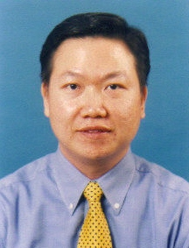
Lawrence Low Peng Kong, MBA
This is a great occasion to pen a few words about my experience with the Akamai University distance learning MBA Program. Deciding to take the Akamai MBA was a tough decision, due to my heavy career and family commitments. Looking back now, this has proved to be one of the better decisions that I had made. I had a great time in going through the nine modules of the program. Akamai has created a favorable environment for learning with relevant and up-to-date tutorials taught by competent and experienced lecturers. At all times, my lecturers made themselves available and willing to provide advisement, not only on issues related to coursework but also related to my career and work life. Indeed, I can feel the transformation resulting from the program, knowing it has contributed a great deal to my career and personnel growth. I can see the world today from a much higher-level perspective and I am able to discuss with people and articulate in a more effective manner. I remember the proud moment back in November of 2005, at the convocation, when I received Akamai's most outstanding academic achievement award. What a proud moment for my wife and son. I wish to thank my family for their tremendous support and understanding during the program. I offer my sincere appreciation to Akamai University and all of my lecturers, who were outstanding, as they guided me throughout the program. I am highly appreciative to EDS Asia Pacific and Dr. Ben Lee for excellent coordination of the residential tutorials. I wish all my course mates a successful learning experience and personal transformation and wish all of you success in career and personal life. Remember, we must know what we want and have the passion to achieve it. Listen to your inner voice, have confidence and a strong conviction and "lets do it" attitude and all the rest will fall right into place. Send email to Lawrence Low Peng Kong
Jennifer Eklund, AA
Hello, my name is Jennifer Eklund from California. In 2006 I decided to further my education in genealogy and attend Akamai University. Upon completion of my studies at Akamai University for my A.A. Degree in Genealogical Studies I was beyond satisfied with the educational experience I received. My instructors and mentor were all supportive and challenging. My courses were thought provoking and I learned more than I could have imagined through my instructors, textbooks, and assignments. I always knew what was expected of me and where my studies were progressing. Akamai University is the best University I have ever attended. I am proud to be a graduate of Akamai University. I encourage anyone who is looking to further their education to put Akamai University on the top of their list. I have not found better instructors and mentors. I have new interests in psychology and online teaching and hope to one day become an online instructor.
Send email to Jennifer Eklund
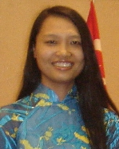
Bui Le Hang, MBA
Hi, there. My name is Lehang from Hanoi, Vietnam. I want to take this opportunity to express my sincere thanks to Akamai University for the high quality of their MBA program. Through this program, I was really transformed into a new and better person. All of my friends in this distance learning MBA share the same thoughts about the program. I was especially fortunate to find Akamai, as they proved to be the very best fit for what I had been looking for. Their program was perfect for me, with a flexible schedule for busy working people, particularly busy workingwomen who work full time during the day, and have family responsibilities in the evening. If you are a workingwoman and you want to pursue study in a quality MBA, Akamai is the best choice for you. You will learn so much from the program, and it will be so easy to apply in your workplace. Through the program, I have improved my self-confidence immensely, with much more energy now to face challenges in my work and overcome difficulties in life. I dare to do things now that I never thought I could do before. What I learned from Akamai has empowered me to achieve a great deal from my studies and work, receiving now several worldwide scholarships, and a promotion to a higher position. The nice thing about the Akamai program is that it did not negatively impact my personal life. I am much more happy now, and more able to balance my working and personal life. If you want to change your life for better, the Akamai MBA is one of the best choices. Send email to Bui Le Hang
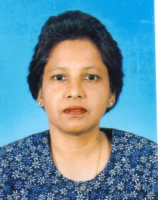
Mariam Abdullah, MBA
To begin with, this program was very interesting. There was never a dull moment. It helped to mold me into a better person, a good leader, and I have learned to think "out of the box". Being a nurse this past 20 years, getting the MBA was a huge challenge for me. To my family, it created a bond and an inner strength for my children to always step forward and expand their horizon. The lecturers were all wonderful. They had aspiring stories to share, as did my course mates. To the EDS Team tat helped coordinate the residential activities of the program, a very big thank you. Send email to Mariam Abdullah

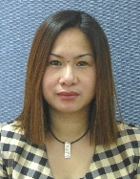
Huynh Thi Thu Huong, MBA
Hello, my name is Huynh Thi Thu Huong, but my friends call me Vivian Hyung, as it is easier when communicating with me. I am a Vietnamese citizen, living in Hanoi. Since 1999, I have been working as Administration Manager for a 100% Japanese-owned company specializing in construction industry. Ten years ago, I had a dream to go abroad for a MBA program, but I could not find a suitable program. As a married woman with two children, and position of manager with high-level duties and responsibilities, I could not leave both family and employment for a long period of time. You can never imagine how happy I was when I learned about Akamai University's MBA distance learning program. The program is quite flexible, permitting me to enhance my qualifications, while upholding my duties as wife and mother, and my employment commitment. At the moment of acceptance to Akamai University, I realized that my life had been turned around and after two years of study and research and with the support of my professors, whom I sincerely respect, I successfully completed my MBA program. The Akamai MBA modules are very practical and useful for Vietnamese students, in general, in the context of the internationalization of the Vietnam economy. The program was properly designed for a person with my responsibilities, a manager needing advanced knowledge and skills. The program helped me to transform myself, assert myself and to perfect myself. I am very proud to be a student of Akamai University. I would like to take this opportunity to express my sincere thanks to Dr. Douglass, President of Akamai University, Dr. Ben Lee, Dr. Pete Ooi, and members of EDS Asia Pacific, who always encouraged me, gave me tremendous support in completing my MBA program. Please send email to Huynh Thi Thu Huong
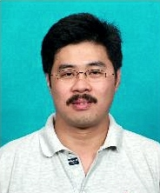
Ng Fook Heng, MBA
Hi to all. My name is Ng Fook Heng; FH for short. I reside in Penang, Malaysia. I completed my MBA in Business Administration in 2006. The Akamai MBA brought my thinking perspective to a different level altogether. I found the program very impressive, not just in terms of the residential tutorial presentations, but also the high level of knowledge and experience of the faculty. What I like best was the clarity and simplicity of instruction, guiding the students in understanding the key points of the subject matter in rapid manner. Even so, students need to do a considerable amount of reading of many books to gain the finest information available. Akamai's teaching method enhanced the way of bringing knowledge to the students in a more interesting and unique way, seemingly the newest teaching methodology in the 21st Century. The nine MBA modules were really fascinating, and easily absorbed due to the quality teaching of the Akamai professors. It was less important that Akamai is not yet fully recognized but more important the depth of knowledge provided, the manner of their teaching, and the numerous opportunities for networking with new colleagues and fellow students. Currently I am working in China, a very dynamic environment that is moving very fast with changes happening almost instantly. I felt the timing of completing the MBA knowledge before beginning my work in China has helped me to understand the cultural and work environment well. I look forward to attending more classes. I want to thank you all for giving me an opportunity to complete the MBA program, and build a wider network of colleagues through the networking opportunities you have provided. Send email to Ng Fook Heng
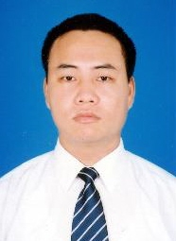
Pham Minh Long, MSc in HRM
Dear friends! I found the Akamai University Master of Science in Human Resources Management interesting and suitable for me in terms of time, tuition fee, method and the content of study. From the beginning of the program in 2005, I was impressed by the logistic activities and services, and helpful support from AITC and EDS, the coordinators of support services for Akamai University. Furthermore, the residential tutorials helped me to overcome difficulties during my program, because I have limited time for study, and preparation of assignments and thesis. I believe I made the right decision for my own life when I chose to join Akamai's program. The Akamai HRM Program provided the international framework of human resource management, both theory and practice in a way that has proved very useful in understanding the fundamentals and applying new learning to my HRM position. Thanks to the knowledge and understanding gained through Akamai, I moved from the status of an HRM practitioner to the status of an HRM professional. I am now under faculty guidance in finaizing my thesis on schedule for completion in 2007. If you need facts, figures and legislation relating to human resources management practices in Vietnam nowadays, especially in telecom industry, please do not hesitate to contact me. Send email to Pham Minh Long
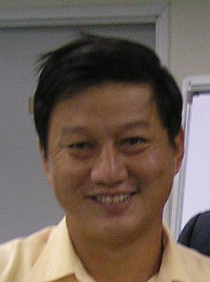
Alan Neo Bock Soo, MBA
I would like to share my experience during and after my Akamai MBA. I have been in business for more than fifteen years. I was enjoying a good return on my business investment from 1991 through 1996, but experienced an serious decline after 1997 due to the financial crisis in Asia. In 2000, with the world recession, business became very difficult and I was faced with a challenge on how to better due business in this difficult period. My customers demanded the same high quality of service but my profit margin was very low. I tried attending motivation courses and seminars conducted by training organizations, but I was not really helped much, since the training was not applicable to my business challenges. I spent time and money in this type of training, and although it helped encourage a positive attitude, these programs did little to help me in the management of my business. I was considering whether or not to terminate my business when I received communication about the Akamai University MBA Program with an offer to attend a trial course. Later, after signing up for the MBA Program and completing the first few assignments, Akamai's program really started to positively impact my business. Akamai encouraged me to individualize my assignments with a focus upon my own business and analyze the problems using the principles and practices taught in the program. This strategic approach became effective and after two years my sales have increase by 50%. Due to what I have learned through Akamai University, I have transformed my business into a more organized company. I now have more time for travel and study and have begun to pursue the DBA. I want to thank the program facilitators for their help to achieve my MBA and transform my thinking and my company. Send email to Alan Neo Bock Soo
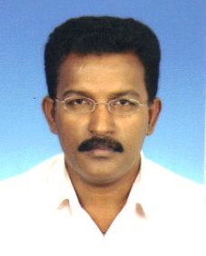
Prabaharan A/L Subramaniam, MBA, DBA
As an engineer, I saw a need for leadership and business knowledge to bring my organization to an excellent position. I have always hoped to run my business in very positive and efficient manner. The accelerated track of the Akamai program is a perfect fit, providing me the opportunity to successfully assume the leadership of a high quality business team in part due to the strong values that are interwoven throughout each course. The course modules are taught by top-notch Instructors, who demonstrate genuine care and concern for the individual student. The coursework is challenging, with a focus on leadership in business and community. I found the investment of my time and resources to be well worth the benefits I have received from this outstanding program. The Akamai DBA program enabled me to be a more effective leader and CEO in my organization, providing me with a legal and ethical framework from which I can analyze business operations and decisions. Learning from competent faculty members and working together with talented an experienced classmates provided opportunities to develop leadership and teaming skills. Although the academic rigor of the program required a significant commitment, I found the intellectual journey well worth the sacrifices. Lastly, I wish to thank the entire faculty, staff and leadership of Akamai University and the Malaysia coordinators, EDS Asia Pacific. Send email to Dr. Prabaharan A/L Subramaniam
Chang Siew Hong, MBA
As a Principal of the Jit Sin Independent High School in Penang State, Malaysia, the Akamai MBA program allow me to study in a very flexible way during weekends and giving me no pressure during study. I have discovered that the knowledge I have learned is very useful in daily activities on the job. I have implemented what I learned and have benefited greatly. I had the excellent opportunity to learn together with course mates from difference industries and backgrounds, sharing experiences and exchanging ideas, and together achieving even better results. I strongly recommend the Akamai MBA program, which is flexible yet high quality and designed for those who want to gain new knowledge and skills, and expand their business network. Send email to Chang Siew Hong
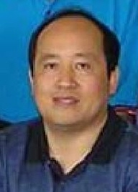
Liu Shou Zheng, MBA
Throughout the Akamai MBA learning process, I found it to be a very practical learning experience. This program covers all of the major elements of business management. Each core module provides an understanding of the importance of each management function while providing the most practical knowledge and applications for our daily work activities. The systemized learning has been very useful to me. The most important aspect of this MBA is the depth of change and improvement to my thinking, enhancing my observation and analysis skills and my abilities at decision-making. The Akamai MBA teaches creativity and skillfulness in business planning and provides hands-on knowledge and skills in a way that can be easily implemented into daily management tasks. In my opinion, this MBA program have given me a better view of the field of business and the ability to think at a higher level in solving problem faced at work, and at the same time it has given me the courage to accept greater challenges and set higher goals in life. Send email to Liu Shou Zheng
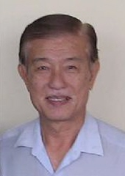
Tan Puah Khin, MBA
Akamai MBA program not only allows the young learner to pursue advanced education and acquire meaningful management knowledge, it also provides opportunities for senior citizens like me tp pursue further higher education. Akamai gave me the opportunity to practice life long learning, activate my mind and brain which can also help to prevent Alzheimer. This program has helped me to keep in touch with the latest trends and developments in 21st Century business. Moreover, it has been an honor for me to earn the MBA degree qualification at such a senior age. For those who wish to upgrade their management skills and achieve their academic goal, I highly recommend them to register for the Akamai degree program. The program is of high quality and practical and it teaches from a perspective of globalization. Send email to Tan Puah Khin
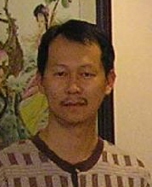
Law Yong Hoe, MBA
I am very thankful to Akamai for providing a very special way of learning, allow working adults who wish to transform in their career to have the opportunity to upgrade themselves. The program includes an emphasis upon individualizing learning in relation to the student's working environment. All the faculty members are good facilitators and provide the latest information and knowledge. I really enjoyed the whole program and thanks to my fellow course-mates for their sharing of experience. Lastly, I do not hesitate to recommend those who want to continue learning to join the Akamai program. You will bring back great knowledge. Thank you. Send email to Law Yong Hoe

