Following the Yellow Brick Road: Bringing Humanitarian Work to Our Communities through the Veteran to Veteran TFT Healing Project
Frost & Miller, (Fall 2017), Following the Yellow Brick Road: Bringing Humanitarian Work to Our Communities through the Veteran to Veteran TFT Healing Project, The Energy Field
Amy Frost, LAAD Program Director, Member, ACEP Humanitarian Committee
Kristin Miller PhD, Trauma Specialist, Member, ACEP Humanitarian Committee
We hide in jobs we hate and in relationships that don’t satisfy us. We pretend to have it all figured out yet we struggle and experience fear. The number of closets we hide in are countless. Leaving the closet means entering the battlefield of life, walking headfirst into our fears and transcending them.
Spiritual Journal Along the Yellow Brick Road, Darren John Main

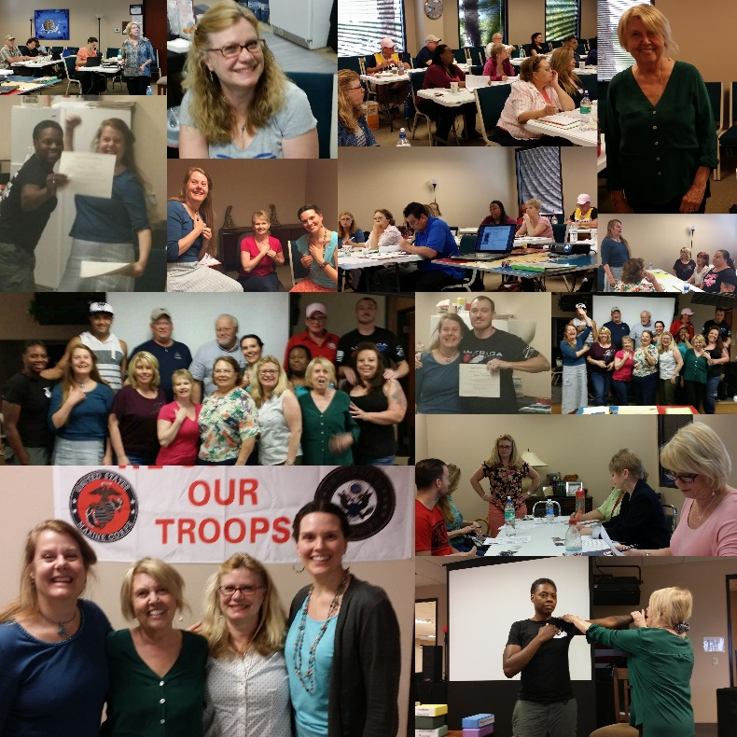
How can we support veterans in coming out of the shadows to face post-traumatic stress, so they can fully be a part of civilian life?

Our three-year journey along the "yellow brick road" may be helpful to you in understanding how to bring humanitarian efforts to your communities. The following describes what we learned in developing the Veteran to Veteran Healing Project, which resulted an effective peer-support model that can be used in any community experiencing stress and trauma.

Take the time to know the populations that you are working with, and their needs.
Veterans are highly trained, competent people who have effectively given service with a very specialized skill set. They are used to doing things by the chain of command, being in control, and not needing help. Admitting weakness or having a problem goes against the ethos of a warrior. Here are some key aspects of being in the military that you need to understand.
- The military’s mission is to close with and destroy the enemy
- Mission first
- Never accept defeat or quit
- Never leave a fallen comrade
- A warrior never shows weakness. Weakness could endanger others’ lives.
- Personal experience is secondary to the team

Veterans are not likely to seek services, admit that they have trauma, and/or sign up for a study. This flies right in the face of warrior consciousness. They do not want to be seen as broken, especially as civilians. A warrior struggles to put the sword and shield down, find purpose in civilian life and to connect -- even without PTSD, but most certainly for those with active PTSD.

The personal door to the veteran is their hidden heroes: family & friends
(Elizabeth Dole Foundation www.hiddenheroes.org).

When a warrior comes home with physical or emotional injury, their first line of care is their family and friends. This is the only way that many veterans get services. They are encouraged, pleaded with or even demanded by their family to finally seek assistance. These family members take on the burden of continual care, and can develop secondary trauma and need support to stay in the game. Without these heroes as an integral part of the project, we would not have been able to reach as many veterans as we did.

Find a way into the community
Our way into the community was through the Veterans Transition Resource Center in Las Vegas, Nevada in partnership with the nonprofit Life After Active Duty (LAAD) www.lifeafteractiveduty.org. LAAD is the central hub of many organizations that serve military, veterans, family, and caregivers.

Groups that now have trained TFT peer support leaders
- Non-profits with veteran support programs
- Veteran Transition Resource Center (VTRC) hosted us; a safe place – known to veterans in Las Vegas
- Elizabeth Dole Foundation Hidden Heroes Program
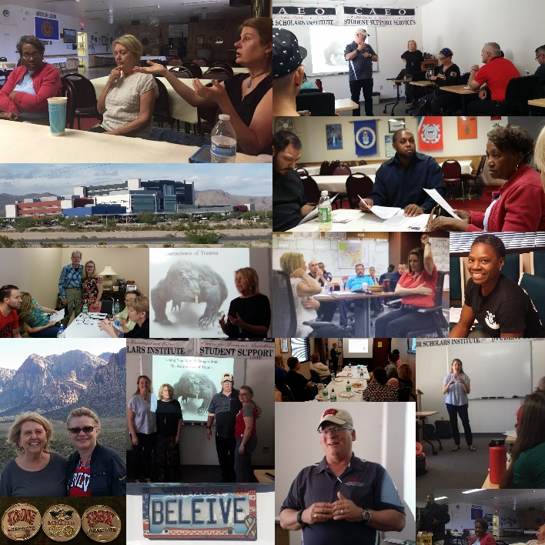
- Vegas Warriors Support Group
- VA Regional Hospital – Mental Health Clinic
- VA – Vet Center (Counseling for Combat vets)
- American Legion Post
- Veterans of Foreign War
- Nevada Women Vets group
- UNLV Military & Veteran Services Center staff
- UNLV Peer-to-peer Advising (PAVE)staff
- Las Vegas & Henderson Fire Departments
- West Care Addiction Centers – Veteran Program Director

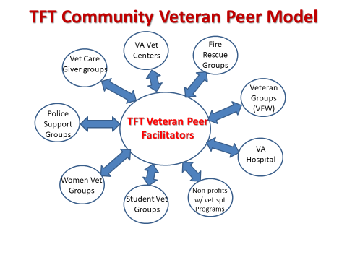
The Journey Along the Veteran to Veteran Yellow Brick Road
The ACEP Humanitarian Committee Veteran to Veteran (V2V) Healing Team was composed of:
- Suzanne Connelly, LCSW - project leader and TFT trainer
- Kristin Miller, PhD - in charge of operations and TFT trainer
- Amy Frost, MA - ground mother in charge of all connections
We made a total of three trips to Las Vegas, Nevada in 2016 and 2017. The original idea of trip number one in June, 2016 was to visit various veterans’ organizations in an effort to create interest in the proposed Veteran to Veteran TFT Peer Support Study. The proposed V2V study was a response to growing interest among energy psychology practitioners in studies using energy psychology techniques with veterans.

During that first visit, the way was paved to interested veterans and others who work with veterans in a multitude of agencies, to participate in a two-day Thought Field Therapy (TFT) tapping technique training. Still focused on creating an opportunity for a study, the V2V team knew this would be a win-win for veterans in the Las Vegas Community, even if it didn’t lead to the hoped-for study.

On the second trip, 27 veterans, and those who work with veterans, enthusiastically showed up for a two-day training. All who participated facilitated other attendees in self-tapping as they learned the easy-to-use self-help technique. This practice was an integral part of that training. It was also perfect practice for the hoped-for study, in which veterans would facilitate the self-treatment of other veterans. Many veterans, and those who work with veterans, experienced partial or total relief from their PTSD symptoms during the training. However, following that first training, and despite the attendees spreading the word within the veteran community, it eventually became obvious that far fewer than the number of veterans required were signing up for the study. The V2V team began to focus on simply training veterans and those who work with veterans.

The V2V team made the final trip to Las Vegas in April, 2017 and offered a second two-day TFT training with the outreach model. Participants from many different community organizations were supported by the V2V Team in bringing it to their individual groups. Amy Frost, MA continues to run a monthly support group in which these participants work on their own stress and trauma and support each other in keeping peer supported TFT alive in their community circles.

This training was also eagerly attended by over 20 veterans and leaders in the veteran community. A few veterans from the prior training showed up to repeat the class. Once more, there were several success stories, as many were partially or totally relieved of trauma symptoms during their training experience.
Success Stories
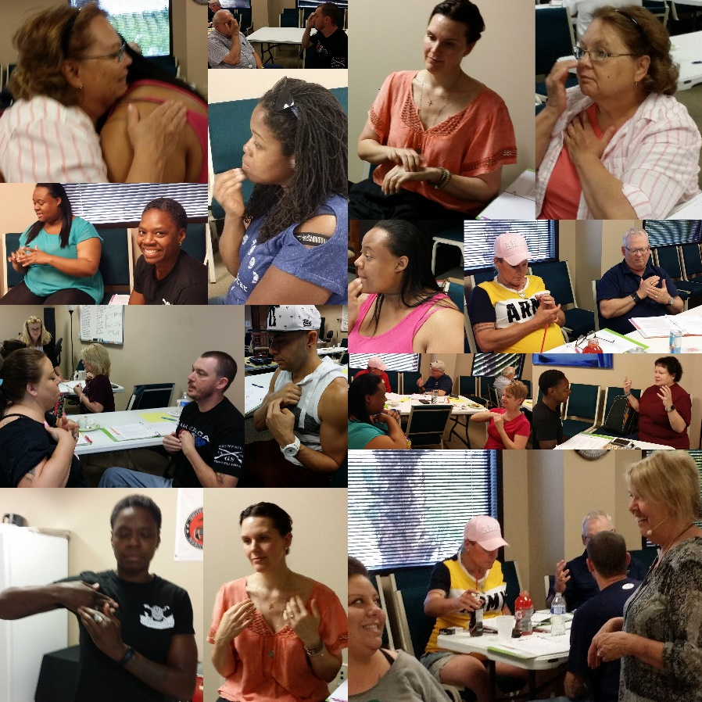
- A leader of several women’s veterans programs, who was previously shy and afraid of talking in front of this group and also afraid to step out into her community as a TFT peer supporter, fearlessly stood up and invited everyone to her group.

- A female veteran reported that she released sexual trauma and long-term developmental trauma. She stated, “I have a say.”
- A quiet veteran volunteered to do a demonstration with Suzanne in front of the entire group. He declared that he is a year out of prison. He tapped through his anger at himself for the "dragon" (PTSD) getting out of his "back yard." Free of self-anger, he delightfully supported others in healing, and came to the second day training with a list of people signed up to tap on.

- A group of three codependents all supporting their veterans at home tapped together, releasing layers of burden, guilt, and fear of asking for their needs to be met. They became okay with being "nuisances", free of trying to have people like them or trying to be enough.

- A veteran tapped through an intense VA hospital experience and is freed of the trauma, ready to serve others.
- A caregiver said, “I never sleep without waking up several times in the night without medication. Last night I tapped myself and with my husband and we slept 6 hours with no interruptions.”

- A hidden hero said, “As the wife and caregiver to a combat vet with PTSD, TBI, and chronic pain, I was very interested in tapping TFT with his pain and other stressors. I had no idea how much these methods would help him and myself in my everyday life managing anxiety and helping with relaxation and sleep.”

- A deeply traumatized vet said, “I have experienced deep connection, release, and acceptance. What a gift to receive and give. It’s simple!!!!! Tune in, reset, move forward, share, TFT works.”

- Our favorite quote came from a pivotal Vegas military/veteran connector when he talked with the group on tapping through performance anxiety. “It’s like cleaning your gun for a mission. You just tap through and once clear, you connect and make things happen.”
What is happening now in the Las Vegas community
When we started this project, we never could have predicted how it would ripple out into the community. And that is one of the gifts of this work.
- The “car tapper”, a retired Marine and recently retired from leadership in a recovery organization, is tapping his way into the VA in a car filled with handouts. He is starting a narcotics anonymous group at the VA and is starting a PTSD Twelve Step Program for veterans and caregivers at the VTRC.

- Circle Leaders from the Southern Nevada and Henderson Fire Departments are actively putting together trainings for all their first responders and are ready to roll into tapping through PTSD with peers.
- A Moapa Valley ACEP member, an expert tapper, is creating a Hidden Heroes program in her city.
- The VA alternative Therapies Outreach Board Members are ready to move TFT into their groups.
- The Vet Center Outreach Coordinator is tapping his groups through trauma and darkness after extreme brain injuries and war trauma.
- The VA Hospital Meditation Group is tapped in, releasing layers of pain and anxiety.
- The Wounded Warrior Vegas group was tapped through by their leader to release pain and anxiety.
- The veteran students support groups at UNLV have a team of tappers to help them and their students move through PTS, academic stress, and life/career transition issues.
This Humanitarian Model Can Translate to Any Population
This model can translate to any humanitarian project. Here are some key steps to take.
1. Gather together peer and professional support personnel who serve those who have experienced trauma in your local community.
2. Train them in TTT,TFT, EFT etc. and the other self-help techniques posted on the new Resources for Resilience website (https://www.energypsych.org/page/resilience).
3. Support them in bringing these methods to the people they serve in more informal settings and within existing groups they participate in. Establish an ongoing central group that can come together monthly to support each other in managing stress and bringing these techniques to their people. If you do not have a person in the community who can support newly trained people as we do in Las Vegas, this could be done through Zoom or another platform.
4. Grow the field of healing and compassion one tap and one person at a time through community action.
5. Challenge them to train at least five people in the use of these skills.
6. Share the successful veteran-to-veteran peer resilience/healing models within your communities.
Next steps in taking the model farther
Kristin Miller is taking the model to her community in Northern California. Elaine is taking it to her community an hour and a half away from Vegas. Jennifer, Veterans’ Service Officer, Umatilla Co, Oregon is excited about starting her own program.

What will you do?

Testimonials from Las Vegas TFT Peers

As a veteran of 24 years, I have discovered the TFT process to be exceptional for myself and those veterans seeking a treatment to enhance the many therapies already being used. It’s a simple protocol that I use to support veterans in need. MAJ (ret) Ross D. Bryant, U.S. Army 1979-2005, Works with transition veterans at UNLV and Las Vegas community.

I have used TFT to deal with flashbacks from combat and seizures since I was trained in September. Using this technique has been very helpful in getting me back into my life. I can use it by myself whenever I need to. Why is soccer loved all over the world? Because all you need is people and a ball. That is why I believe TFT needs to get into the hands of veterans and their family. It is simple and effective. Frank Spady, Chairman, National Veterans Foundation
I was able to attend this amazing "Thought Field Therapy Training" at the Veterans Transition Resource Center late last year. This is a simple technique that you will be taught to use upon yourself to relieve any type of stress or anxiety type symptoms. Everyone that was trained wants to share this technique with others in our community; and then they can share it with others who would benefit with this training too. We want to touch as many people and lives as we can! Jan Hawkins, UNLV Career Connect Job Developer, Supports Veterans in Career Transitions

I have been able to use the TFT protocols to keep sane while supporting others in extreme crisis this past year. I have used it to help people in career transition, as anxiety stops them from taking action to make a call or set up a plan for the next steps on their career plan. It is becoming second nature to use it as a stress management tool for myself and with those I work with daily. Amy Frost, Programs Director, Life After Active Duty.
I have used TFT to transition from a stressful career to a calling. TFT helps me stay focused, without the anxiety from giving up a higher income position. I have also used TFT with several military friends suffering from PTSD. This has allowed them to calm down and have some type of control. USAF MSgt (ret) Janet Napiorkowski, Registered Behavior Technician, Reiki Practitioner works with Veterans/Military and their children (Masters in special-education with an autism endorsement)

About the Authors

Amy Frost, MBA, MA in Spiritual Psychology, is a trainer and facilitator. Amy grew up in the military, lost her husband Tom in Desert Storm and part of her mission is supporting veterans and their caregivers in their life transitions. She is the Programs Director for Life After Active Duty.

Kristin Miller, PhD, DCEP is a psychologist specializing in the treatment of trauma. Energy psychology empowers her clients to rapidly reach the energetic core of trauma and transform. She is part of ACEP’s Resources for Resilience project, and was one of the team members for the Veteran to Veteran Project.

